**Hanzla saeed**

**472684**

**Section C**

**Lab manual 8(Lab Tasks)**

**Q#1**

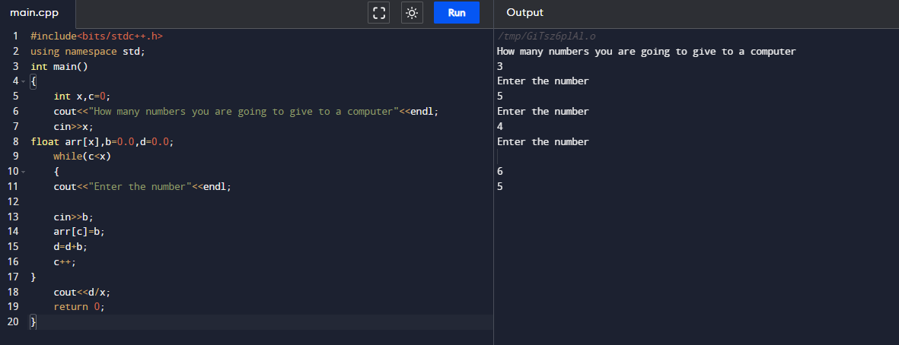

**Q#2**

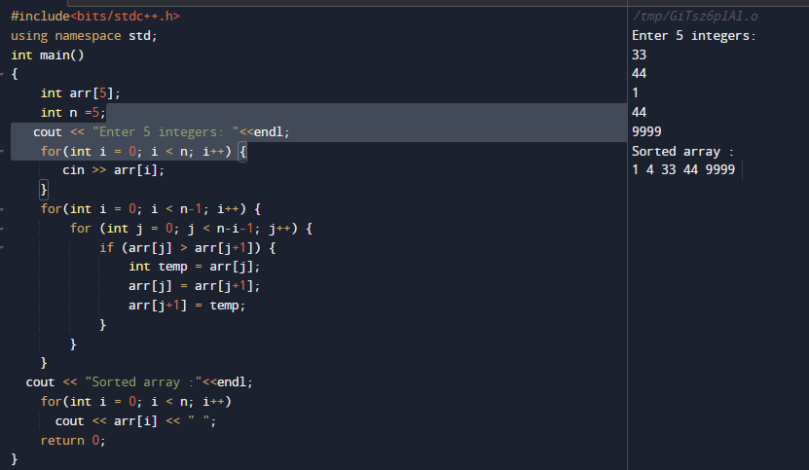

**Q#3**

